**Statement of Work**

# **for**

## **Color Detection**

By: - Parth Shah (100799064)

Guided by: - Prof. Marcos Bittencourt

Subject: - 1002 – 02 AI Algorithms

**Index**

|  |  |  |
| --- | --- | --- |
| **Sr.no.** | **Title** | **No.** |
| 1 | Summary | 3 |
| 2 | Model | 3 |
| 3 | Data | 3 |
| 4 | Requirement | 4 |
| 5 | Plan | 5 |
| 6 | Preliminary Data Manipulations | 5 |
| 7. | Feature Engineering | 6 |
| 6 | References | 7 |

1. **Summary**

Identify vivid colors can sometimes become difficult for humans and to over come this and differentiate colors with minute difference only computer system can do it but not humans with normal eyes. Here computer sensors work to identify the colors and generate results from the data present in the database. For this we have total 865 different colors in the database which helps to get the results accurate these colors are made making combination from RGB colors. This AI method helps to create new colors also.

This AI method can be implemented in applications where we can use app to form operations where we can identify color of particular objects and also on other hand can also make own colors and identify which is that color. This app can be used to form new combinations where it can be used to see how it actually looks on particular objects. So, then the app will find the shortest difference from the color in the database and will generate result.

For this OpenCV and Pandas are used as python library. Then first directly image path will be given from using argparse library. Then we need csv files will be used and uploaded as database in pandas. Then the value will be detected and calculation will be done from this which will make the result and from assumption the formula will be used to generate the output or result. The formula can have color combination.

1. **Model**

There are many different possible **models** like

* RGB,
* HSV,
* HLS,
* HIS and
* NCC

For this **RGB model** will be used where there will be cube formation

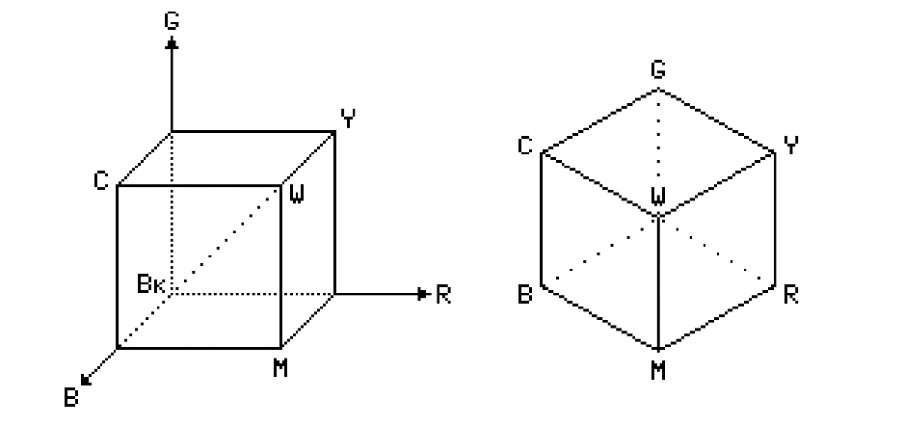

* Dotted line of cube which is diagonal having same amount of RGB (Red, Green and Blue) colors are forming gray color.
* RGB color model is considered as hardware model which is also used in many methods like image capturing, processing and rendering devices.

Camera many times can even fail due to lighting conditions so that is important to take care for the proper results as all the colors needs to be properly reflected in camera lens so then only it can have accurate results. This is also possible with human if human eyes try to identify the color in dark area or environment.

1. **Data Requirements**

* Color data set where all different colors are there with their property.
* It can be in any form but RGB is preferred format.

1. **Data**

* Github: - https://github.com/codebrainz/color-names/blob/master/output/colors.csv
* Data.world: - <https://data.world/datasets/color>
* Color Science: - <https://www.colour-science.org/colour-datasets/>
* Color Constancy: - <https://colorconstancy.com/evaluation/datasets/>

1. **Plan**

|  |  |  |
| --- | --- | --- |
| **Task** | **Perform by** | **When (dd/mm/yy)** |
| Collecting Data | Parth Shah | 03/11/20 |
| Analyzing Data | Parth Shah | 05/11/20 |
| Cleaning Data | Parth Shah | 07/11/20 |
| Making Algorithms | Parth Shah | 10/11/20 |
| Making models | Parth Shah | 15/11/20 |
| Training model | Parth Shah | 25/11/20 |
| Developing Report | Parth Shah | 27/11/20 |
| Developing Scoreboard | Parth Shah | 29/11/20 |
| Developing DashBoard | Parth Shah | 30/11/20 |

1. **Preliminary Data manipulations**

Since we just idea with respect to the shade of the uncommon thing in the picture, a raised degree of detail was likely going to confuse the checks. Moreover, more unobtrusive pictures accumulated less figuring. Coming to fruition to performing tests on a couple of pictures we saw that a size of 100×100 was a sensible compromise. We really had the use occasion of a style electronic business site as a principal concern while engineering this contraption, and it prompted the chance of an additional progression to improve our concealing zone gadget: directing. The thing we are amped up for is essentially sure to be secured inside the image, directing honors us to reduce the size of the establishment picture. Regardless of the way that managing improves results as a rule, holding under 90% of the central picture doesn't work exceptionally with establishment departure while thinking about a heterogeneous informative assortment. This is an outcome of the major article, a piece of the time showing up along the edges of the picture considering which it gets considered as the "establishment" for following figurines.

1. **Feature Engineering**

Feature Engineering is the second step in the AI pipeline, takes in the etching times from the essential turn of events — figure orchestrating — and an unrefined dataset that should be refined. Feature masterminding methodology building features for each name while isolating the data used for the portion subject to the etching's cutoff time to make genuine features. These features and names are then passed to exhibiting where they will be used for setting up an AI appraisal. While join organizing requires name times, in our general critical framework, it isn't hard-coded for unequivocal inscriptions identifying with simply a solitary speculation issue. In case we made our part masterminding code for a singular issue — as feature orchestrating is conventionally moved nearer — by then we would have to re-try this suffering progression each time the cutoff focuses change. Considering, we use APIs like Feature tools that can assemble features for any strategy of names without imagining that changes should the code. This infers for the customer beat dataset, we can manage distinctive needing issues — imagining mix every month, each other week, or with a lead season of two rather than one month — using definitely a practically identical piece orchestrating code.

1. **References**

<https://github.com/codebrainz/color-names/blob/master/output/colors.csv>

<https://towardsdatascience.com/color-identification-in-images-machine-learning-application-b26e770c4c71>

<https://data-flair.training/blogs/project-in-python-colour-detection/>

<https://www.researchgate.net/publication/259821006_Color_recognition_algorithm_using_a_neural_network_model_in_determining_the_ripeness_of_a_Banana>

<https://www.kdnuggets.com/2020/03/20-machine-learning-datasets-project-ideas.html>

<https://www.cs.ubc.ca/grads/resources/thesis/Nov99/Vladimir-Kravtchenko.pdf>

<https://data-flair.training/blogs/opencv-python-tutorial/>

<https://www2.cs.sfu.ca/~colour/publications/CRA-2002/index.html>